**YASASII WEB**

Hospital Information System

**TARIFF SETTING & TARIFF CHARGE**

**Date (25-October-2023)**

**Version (V1.1)**

|  |  |  |  |  |
| --- | --- | --- | --- | --- |
| Sithu 25th Oct 2023 |  |  |  |  |
| **Prepared by/Date** |  | **Reviewed by/Date** |  | **Approved by/Date** |

**Revision History**

|  |  |  |  |  |  |
| --- | --- | --- | --- | --- | --- |
| **Version** | **Date of Revision** | **Description of Change** | **Reason for Change** | **Author** | **Approved By** |
| 1.1 |  |  |  |  |  |
|  |  |  |  |  |  |
|  |  |  |  |  |  |
|  |  |  |  |  |  |
|  |  |  |  |  |  |

Contents

|  |  |
| --- | --- |
| **Sl No.** | **Task** |
| 1 | Task 1: Tariff setting |
| 2 | Task 2: Tariff Charge Selection |
|  |  |
|  |  |
|  |  |
|  |  |

# Task 1: Tariff setting

**Description:**

|  |
| --- |
| This task is to have the functionality of defining the tariff. |

**Actors :**

|  |
| --- |
| Billing, accounts, finance personnel. |

**Pre conditions:**

|  |
| --- |
| 1. User has logged into the application. 2. The user has rights to access the Masters ->Tariff Setting screen. |

**Post conditions:**

|  |
| --- |
| Tariff will be saved against the scheme. |

**Main functionalities:**

|  |
| --- |
| 1. To define the tariff against the scheme. |

**Mock/Sample UI:**

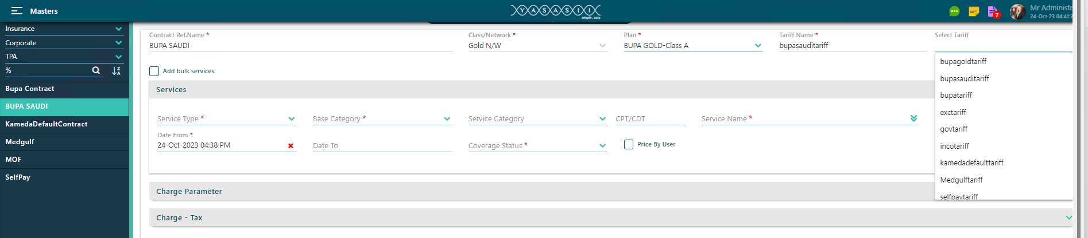

**Fig 1 : Tariff Setting**

**Normal Flow 1: Save**

|  |
| --- |
| 1. User opens masters module navigates to RCM and selects “Tariff Setting”. 2. User selects contract reference.name, system loads class/network in next drop-down. 3. User selects class/network, system loads plan in next drop-down. 4. User selects plan/plans and define the tariff name (user define text-box) for our contract. 5. User select Tariff from Drop-down already defined tariffs for copy tariff functionality from other defined contract tariff, read-only. (Fig 1) 6. User clicks on Check box ticked for “Add bulk services” (Fig 2) |

**Mock/Sample UI:**

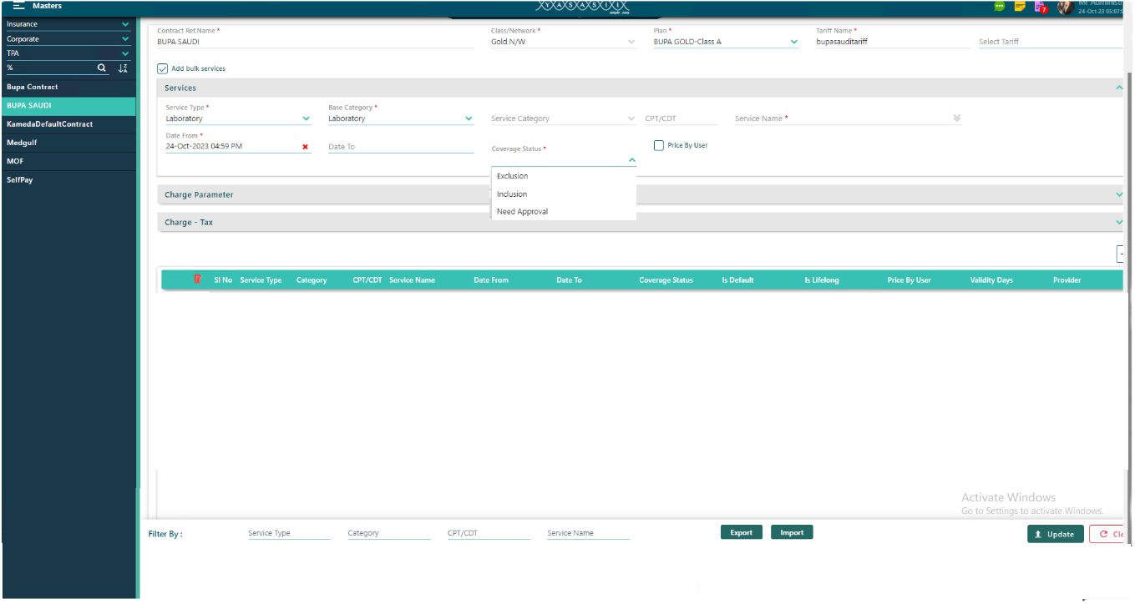

Fig 2

|  |
| --- |
| 1. User choose the “service type” as Laboratory, Pharmacy, Radiology, Procedures and Other charges. 2. User choose the “Base category” for the service type with Date select Date from and coverage status as Exclusion, Inclusion, Need approval. 3. Click on Import. Warning message to update the tarriff as “yes”. 4. Attach the tarriff import excel file and save. |

**Mock/Sample UI:**

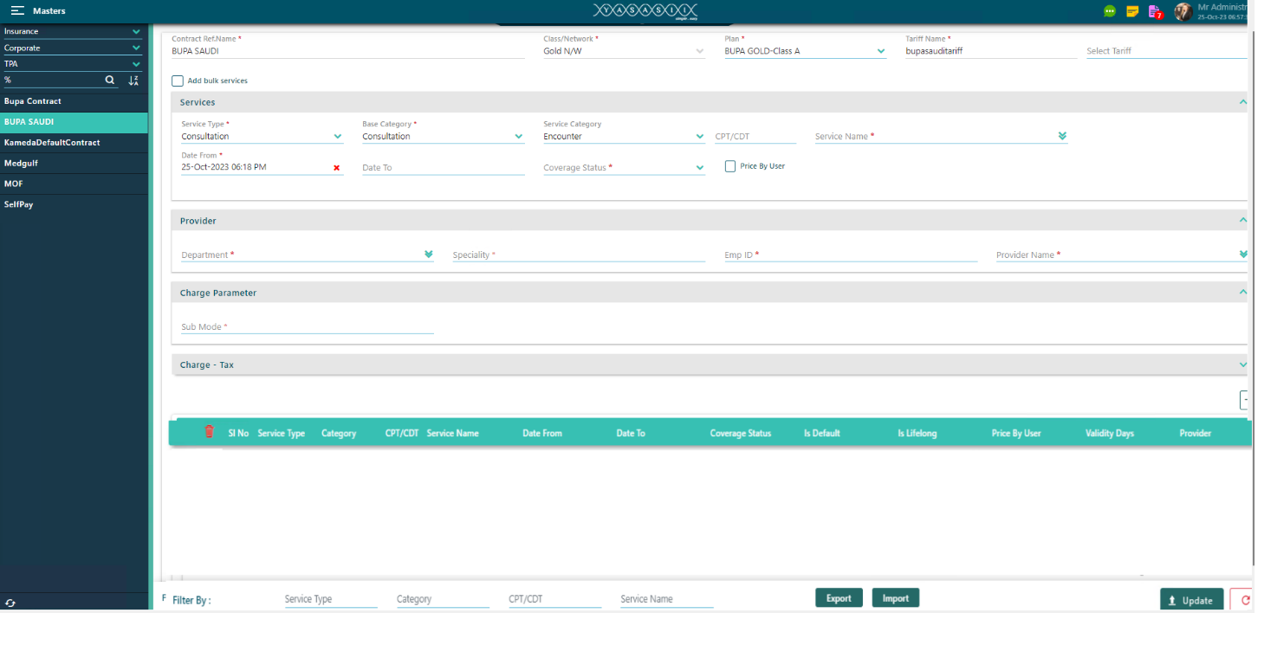

Fig 3

|  |
| --- |
| 1. User clicks on Check box unticked for “Add bulk services” (Fig 3) 2. User choose the “service type” as Consultation. 3. User choose the “Base category” for the service type as consultation with Date select Date from and coverage status as Exclusion, Inclusion, Need approval. 4. If user clicks on the check box ticked for Price by user, it will take the already defined price for the consultation charge, else if the check box is unticked for Price by user, user can define the price for the service type category for each consultation, lab, radiology etc. 5. System enables provider accordion and loads related categories in category drop-down. 6. User selects provider. Department, specialty and Emp Id will autofill. 7. When service type Consultation is not selected then provider accordion should be collapsed and should not be available for expansion. 8. Only Consultation category should be loaded when consultation option is selected. 9. Category, code and service should be loaded as it is loading in encounter billing. 10. Category is single selection, Code text box, Service Category is searchable drop-down. 11. Service name will display in dropdown based on the service category. 12. Coverage status in drop-down to choose as “Exclude, include, need approval”. 13. If “Exclude” is selected then the service will be excluded from the contract. 14. If “Include” is selected then the service will be included in the contract. 15. If “Need Approval” is selected then the service will go for approval as per the contract 16. Visit mode & Sub Mode is multi selection drop-down. 17. Base charge should be loaded from default tariff for the selected service. 18. Contract charge is a charge we are going to set for the service in the contract. 19. Adjustment type is + or - as markup for increment or discount respectively. 20. Adjustment percentage can be defined as percentage and same time Adjustment amount should be calculated and vice versa. 21. Taxable amount can be displayed as net amount and can be changed by the user. 22. Taxable amount cannot be defined more than the net amount. 23. Tax1Per can be defined as tax percentage and Tax1Amt should be calculated on taxable amount and vice versa. 24. Tax2Per, Tax3Per, Tax4Per, Tax5Per not required for Almeswak. Have the option to hide these fields as well. 25. Final amount is the amount which inclusive of all taxes. 26. Tax caption for UI should be defined in lookup with lookup type as “Tax Name”. 27. The tax name caption should display as per the lookup definition. 28. Data should be loaded into the grid after the click of add button and should be displayed as mentioned. (fig 1) 29. Data should be cleared from all accordion but contract section should not be cleared and should be disabled for further change. 30. Adding of duplicate data should not be allowed into the grid. 31. Edit and delete option in grid should be available to do the edit and delete the data respectively for the first save only. 32. Able to do the filter with service type, category, code and service name option   **Search and View :**   1. Class/Network can be searched in search section with contract ref. name, and can be displayed into the search list. 2. Class/Network can be selected from the search list and details of the class should be loaded into contract section and corresponding tariff details should be loaded into the item grid. 3. This is called view mode and, in this mode, the save button should be disabled and also the delete button should be disabled and edit button should be enabled. 4. In view mode user can click the edit button from the grid and it will display the data into their respective fields for the selected item of the grid. 5. Able to do the filter with service type, category, code and service name option. |

**Mock/Sample UI:**

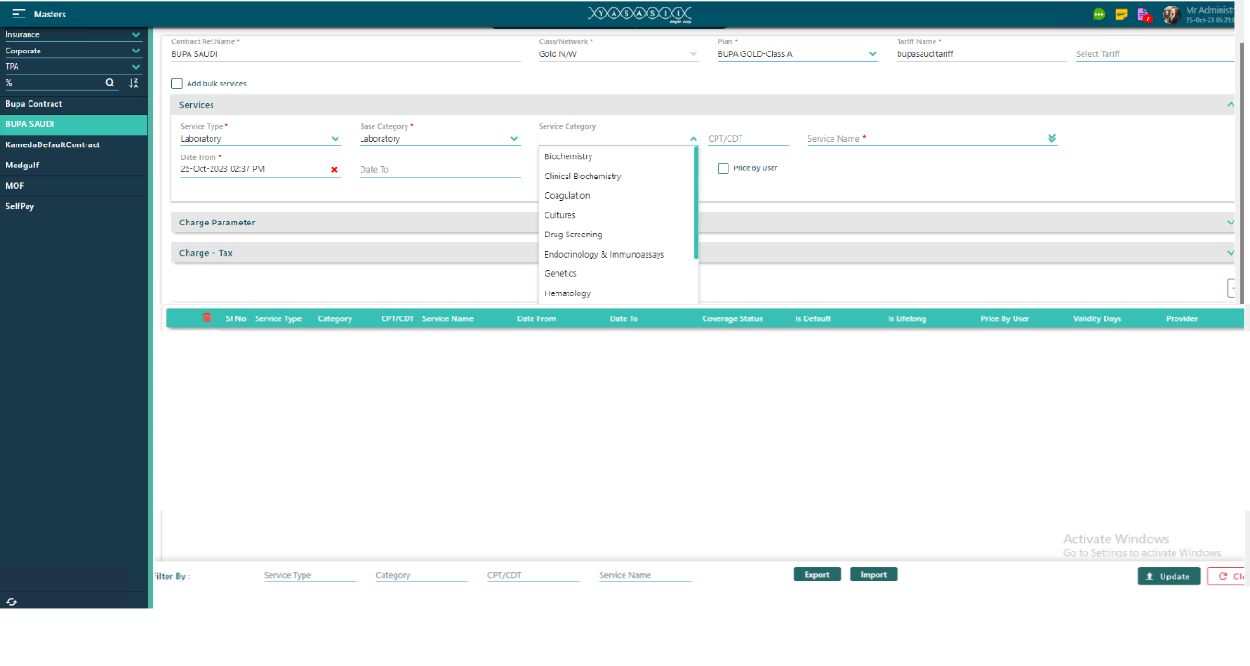

Fig 4

|  |
| --- |
| 1. User clicks on Check box unticked for “Add bulk services” (Fig 4) 2. User choose the “service type” as Laboratory, Pharmacy, Radiology, Procedures and Other charges. 3. User choose the “Base category” for the service type as Laboratory, Pharmacy, Radiology, Procedures and Other charges with service category for the service type from drop-down with Date select Date from and coverage status as Exclusion, Inclusion, Need approval. 4. If user clicks on the check box ticked for Price by user, it will take the already defined price for the consultation, else if the check box is unticked for Price by user, user can define the price for the service type category. 5. When service type as Laboratory, Pharmacy, Radiology, Procedures and Other charges then provider accordion should be collapsed and should not be available for expansion. 6. Able to add individual services also by choosing the service type for each defined by price by user and by default price. 7. Option to define the copay/deductible also for the service group and individual services in tariff setting (Fig 5) |

**Mock/Sample UI:**

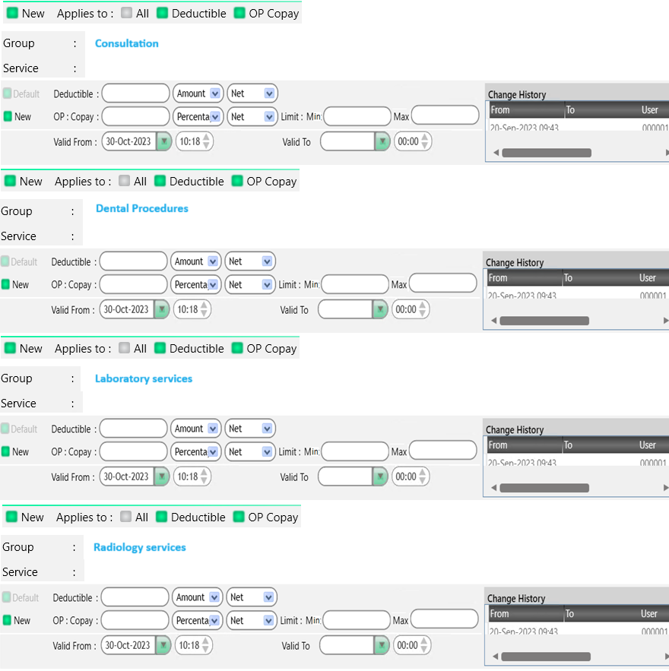

Fig 5

**Normal Flow 2: Search**

|  |
| --- |
| 1. User opens master’s module and navigates to RCM and selects “Tariff Setting”. 2. User selects contract reference name, system loads class/network into the list. |

**Alternate Flow 1: View tariff details for selected class**

|  |
| --- |
| 1. User opens masters module and navigates to RCM and selects “Tariff Setting”. 2. User selects contract reference.name, system loads class/network into the list. 3. User selects class/network and clicks on “Edit button” option. 4. System loads contract information in contract section along with the tariff item list into the grid. 5. Also system should disable the save button 6. Also system should disable delete button and enable the edit button in grid. 7. User can take any item for view purpose from the grid by clicking the edit button. 8. System should load the item details in respective fields. |

**Business Rules/Validations:**

|  |
| --- |
| 1. Contract Ref. Name should be added in contract table as new column “reference.name”. 2. Contracts should be loaded from contract table into the “Contract Ref.Name” drop-down. 3. Contract Ref. Name selection is mandatory. 4. Contract Ref. Name selection is single selection, searchable and without all option. 5. Class/Networks should be loaded from class table into the “Class/Network” drop-down based on the contract selection. 6. Class/Network selection is mandatory. 7. Class/Network selection is single selection, searchable and without all option. 8. Class/Networks should be loaded from class table into the “Class” drop-down based on the contract selection. 9. Plan selection is mandatory. 10. Plan selection is multi selection, searchable and with all option. 11. Plans should be loaded from plan table into the “Plan” drop-down based on the contract and class selection. 12. Ideally, we will be having a separate tariff table for each contract and that table will be defined from this screen only but right now need to create a tariff table from back-end and the name like traiff1 or something else for every new contract. 13. Tariff name will be available in plan and all plan will be having the same tariff name for a contract. Thus tariff name should be taken once from the selected plans and should be displayed in read-only text box. 14. Date from is validity date and it is mandatory and should load default value as current date time. 15. To date is optional. 16. Site selection is muti selection drop-down. 17. Tariff is defined for consultation, laboratory, other services, pharmacy etc.(fig 1) 18. When consultation is selected then only provider accordion should be available for expansion. 19. Department, specialty, empid, provider name should be loaded as it is loading in encounter billing screen. 20. Department is single selection drop-down. 21. Specialty is multi selection drop-down. 22. When Consultation is not selected then provider accordion should be collapsed and should not be available for expansion. 23. Only consultation category should be loaded when encounter option is selected and same is applicable for other services, radiology etc. 24. When we choose service type as Pharmacy, then provider accordion and charge tax should be collapsed and should not be available for expansion. 25. Category, code and service should be loaded as it is loading in encounter billing. 26. Category is single selection. 27. Code is a text box. 28. Service is searchable drop-down. 29. If “Exclude” check-box is checked then the service will be excluded from the contract. 30. Visit mode is selection drop-down for sub mode as ER and OP. 31. Base charge should be loaded from default tariff for the selected service. 32. Contract charge is a charge we are going to set for the service in the contract. 33. Adjustment type is + or - as markup for Increment or discount respectively. 34. Adjustment percentage can be defined as percentage and same time Adjustment amount should be calculated and vice versa. 35. Taxable amount can be displayed as net amount and can be changed by the user. 36. Taxable amount cannot be defined more than the net amount. 37. Tax1Per can be defined as tax percentage and Tax1Amt should be calculated on taxable amount and vice versa. 38. The fields for Tax2Per, Tax3Per, Tax4Per, Tax5Per not required for Almeswak, so we need to hide these fields as well for Almeswak. 39. Final amount is the amount which inclusive of all taxes. 40. Tax caption for UI should be defined in lookup with lookup type as “Tax Name”. 41. The tax name caption should display as per the lookup definition. 42. Data should be loaded into the grid after the click of add button and should be displayed as mentioned. (fig 1) 43. Data should be cleared from all accordion but contract section should not be cleared and should be disabled for further change. 44. Adding of duplicate data not allowed into the grid. 45. Edit and delete option in grid should be available to do the edit and delete the data respectively for the first save only. 46. Filter provision available with service type, category, code and service name option.   **Search and View :**   1. Class/Network can be searched in search section with contract ref. name, and can be displayed into the search list. 2. Class/Network can be selected from the search list and details of the class should be loaded into contract section and corresponding tariff details should be loaded into the item grid. 3. In view mode the save button and delete button is disabled and edit button should be enabled. 4. In view mode user can click the edit button from the grid and it will display the data into their respective fields for the selected item of the grid. 5. Able to do the filter provision with service type, category, code and service name option. |

# Task 2: Tariff Charge Selection

**Description:**

|  |
| --- |
| This task is to have the functionality of fetching the tariff charge. |

**Actors :**

|  |
| --- |
| Billing, accounts, finance personnel. |

**Pre conditions:**

|  |
| --- |
| 1. User has logged into the application. 2. The user has rights to access the FO->Billing screen. |

**Post conditions:**

|  |
| --- |
| Tariff will be fetched against the scheme, Providers etc. |

**Main functionalities:**

|  |
| --- |
| 1. To fetch the tariff . |

**Business Rules/Validations:**

|  |
| --- |
| Consultation Encounter  --------------------------------------------------  1.Select Provider By typing provider name, all the matching provider names are listed and user can select provider from those provider names  2.User also can select by typing employee id  3.All the details of Provider such as Department, Specialty, Employee Number, Category, Code, Service Name, Base Price filled by selecting provider employee id  4.User can save encounter by clicking plus icon  5.User can cancel saving encounter by clicking cross icon  6.Base Price of provider varied based on following factors  a. visit mode  Based on visit mode Consultation charge varied. Visit modes can be OP or ER  b. visit sub mode  visit sub mode can be OP or ER. On visit mode service charge will differ  c. nationality  nationality charge added base charge  d. weekday  Weekday charge and weekend charge will be different. So consultation charge will vary  e. priority  Here Priority charge Added with base charge to get Consultation charge  f. session  Here session charge Added with base charge to get Consultation charge  g. specialty  Selecting Service  1.Select Provider  2.Once a provider selected by user, Department, Specialty and Employee Number of provider get displayed  3.User can clear all details by clicking cross icon  4.For adding new services click on the down arrow which is placed on Add New Order bar, Opens a new tab  5.Category of the service filled as All and Priority as routine as default values while loading  6.User can change Category, As Initially Category filled with All, All the services are listed in drop down  7.By typing service name, all the matching service names are listed and user can select service from those services  8.Once service name selected, Base Price, execution locations are filled  9.Category, Service name, priority and execution locations are mandatory  10.User can save service by clicking plus icon  11.User can cancel adding service by clicking cross icon  12.Multiple services can add by clicking add icon  13.Base price of service loaded based on following factors  a. visit mode - Based on visit mode registration charge selecting. Visit modes can be OP or ER  b. visit sub mode - visit sub mode can be OP and ER as visit mode service charge will vary  c. nationality - based on nationality, nationality charge added with base charge  d. gender  e. weekday - Weekday charge and weekend charge will be different. week day charge will be added with base charge to get service charge  f.priority - Here Priority charge Added with base charge to get service charge  g. session - Here session charge Added with base charge to get service charge  h. lab name - Here Lab charge Added with base charge to get service charge |

**Mock/Sample UI:**

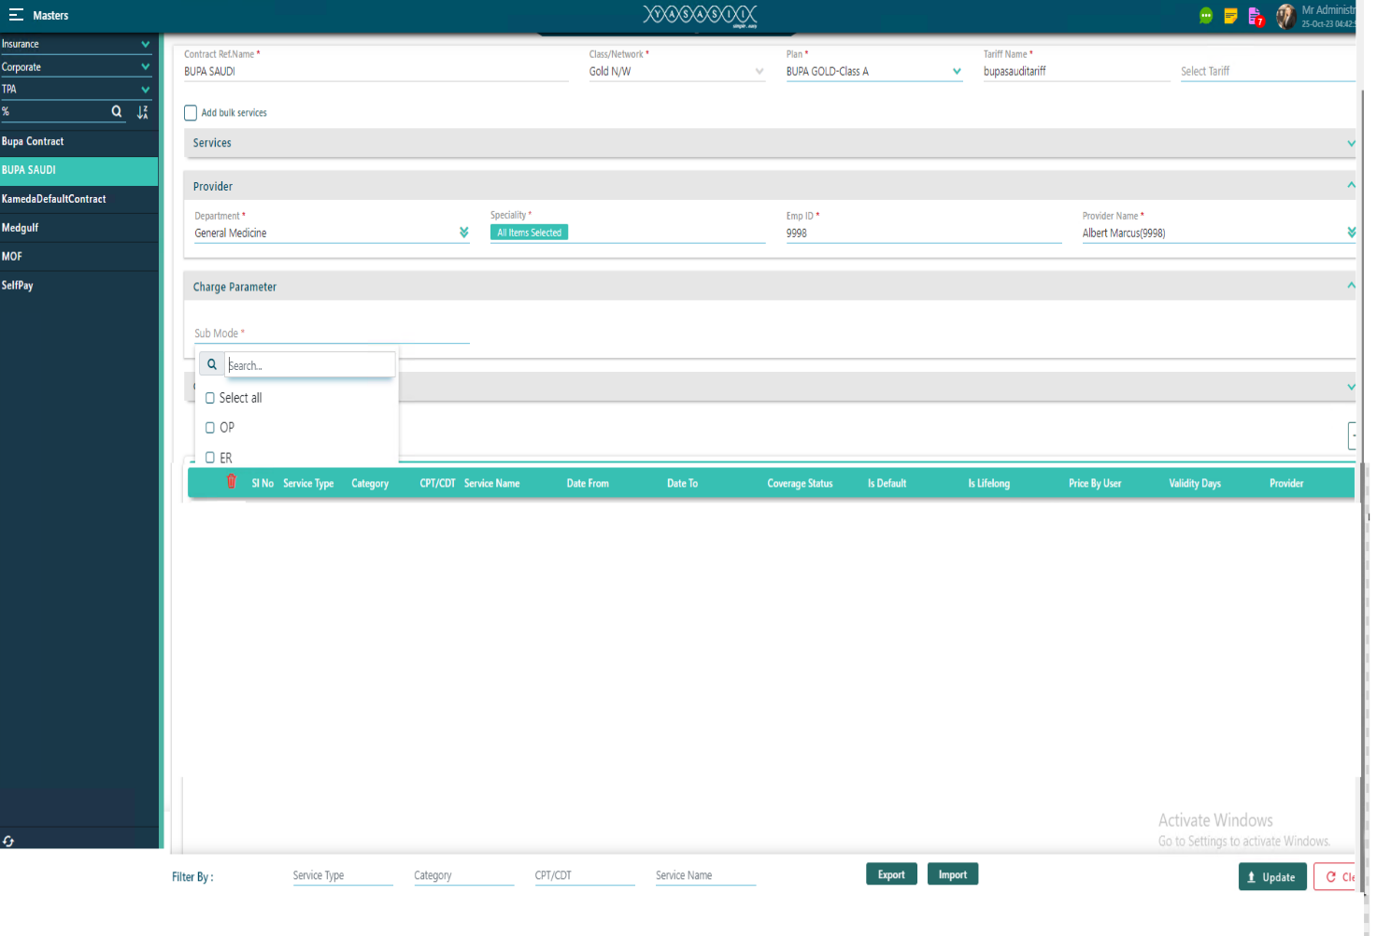

Fig 5

|  |
| --- |
| 1. User selects Charge Parameter from drop-down for the sub-mode as OP or ER. (Fig 5) 2. For the charge tax, User enters Base charge, contract charge, selects adjustment type as increment or discount. (Fig 6) 3. User can enter either adjustment percentage or adjustment amount. 4. If user enters adjustment percentage, then system calculates amount. 5. If user enters adjustment amount, then system calculates percentage. 6. Optionally user can enter the taxable amount. 7. If user enters the tax percentage, then tax amount should be calculated and displayed, if tax amount is entered then tax % should be calculated and displayed in respective fields. 8. User clicks the add button, details get added into the grid. 9. User clicks save button 10. System saves the details. |

**Mock/Sample UI:**

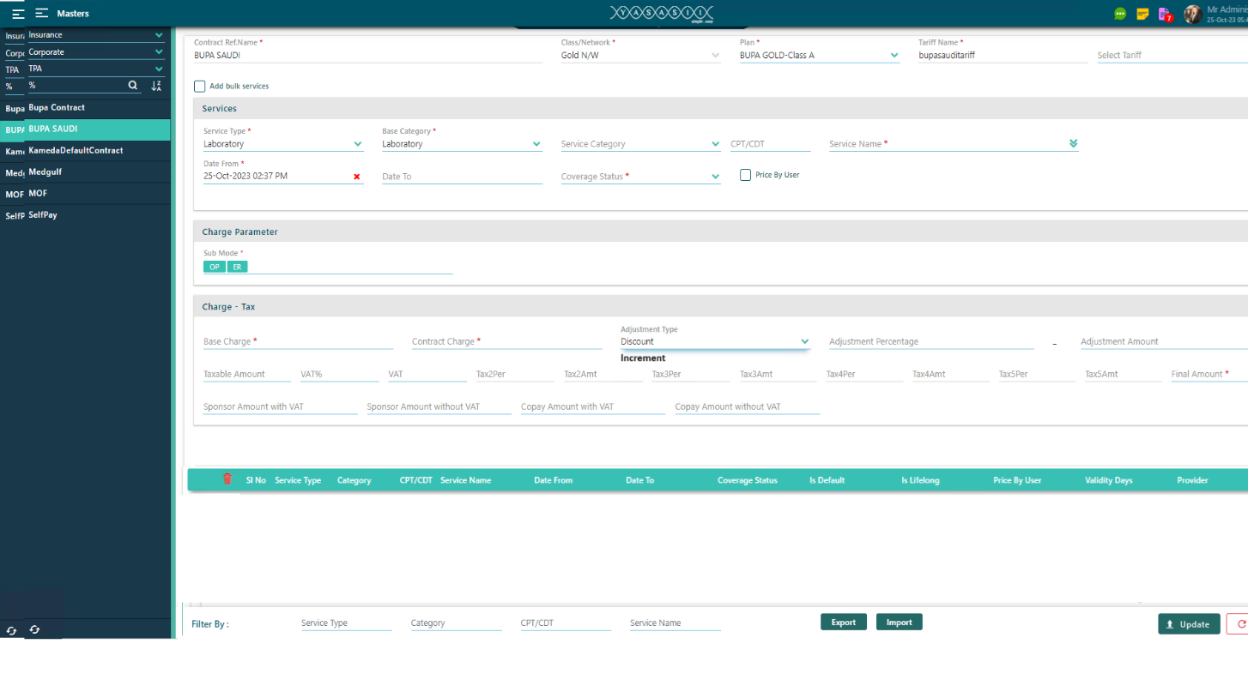

Fig 6